JAVA HACKATHON

3a) Data Types:
Write a Java program to store and display the following details of a waste collection vehicle:
Vehicle number – integer
Waste collected in kilograms – decimal value
Number of collection points – integer
Vehicle status – character
Use appropriate Java data types for each value and display all the details.
ANSWER:--
public class WasteVehicleDetails {
public static void main(String[] args) {

int vehicleNumber = 1111;
double wasteCollectedKg = 264.45;
int collectionPoints = 18;
char vehicleStatus = 'A';

System.out.println("Vehicle Number: " + vehicleNumber);
System.out.println("Waste Collected KG: " + wasteCollectedKg);
System.out.println("Number of Collection Points: " + collectionPoints);
System.out.println("Vehicle Status: " + vehicleStatus);
}
}
OUTPUT :---
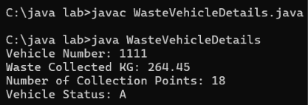

3b) If-Else Condition:

Write a Java program to check the waste collection status based on the amount of waste collected. Read the waste collected in kilograms.

If the waste collected is 100 kg or more, display "Collection Target Achieved".
Otherwise, display "More Waste Collection Required".
Use an if-else statement.

Answer:---
import java.util.Scanner;

public class WasteStatusChecker {
public static void main(String[] args) {
Scanner scanner = new Scanner(System.in);

System.out.print("Enter the amount of waste in kilograms: ");
double wasteCollected = scanner.nextDouble();

if (wasteCollected >= 100.0) {
System.out.println("Collection Target Achieved");
} else {
System.out.println("More Waste Collection Required");
}

scanner.close();
}
}

Output :---
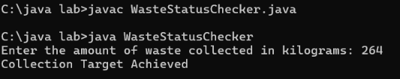

3c) Methods:

Write a Java program to calculate the total waste collected from two collection points using a method.

Create the following method:

calculateTotalWaste(double point1Waste, double point2Waste)
The method should return the total waste collected. Read the waste collected at the two collection points from the user, call the method, and display the total waste collected.
Answer:---
import java.util.Scanner;

public class WasteCollection {

static double calculateTotalWaste(double point1Waste, double point2Waste) {
return point1Waste + point2Waste;
}

public static void main(String[] args) {
Scanner sc = new Scanner(System.in);

System.out.print("Enter waste at Point 1: ");
double point1Waste = sc.nextDouble();

System.out.print("Enter waste at Point 2: ");
double point2Waste = sc.nextDouble();

double totalWaste = calculateTotalWaste(point1Waste, point2Waste);
System.out.println("Total waste collected: " + totalWaste);

}
}

Output :---
